**2. spring-rest-Handson**

**REST - Get country based on country code   
  
Write a REST service that returns a specific country based on country code. The country code should be case insensitive.  
  
Controller: com.cognizant.spring-learn.controller.CountryController  
Method Annotation: @GetMapping("/countries/{code}")  
Method Name: getCountry(String code)  
Method Implemetation: Invoke countryService.getCountry(code)   
Service Method: com.cognizant.spring-learn.service.CountryService.getCountry(String code)  
  
Service Method Implementation:**

* **Get the country code using @PathVariable**
* **Get country list from country.xml**
* **Iterate through the country list**
* **Make a case insensitive matching of country code and return the country.**
* **Lambda expression can also be used instead of iterating the country list**

**Sample Request: http://localhost:8083/country/in  
  
Sample Response:**

**{**

**"code": "IN",**

**"name": "India"**

**}**

**Folder Structure:**

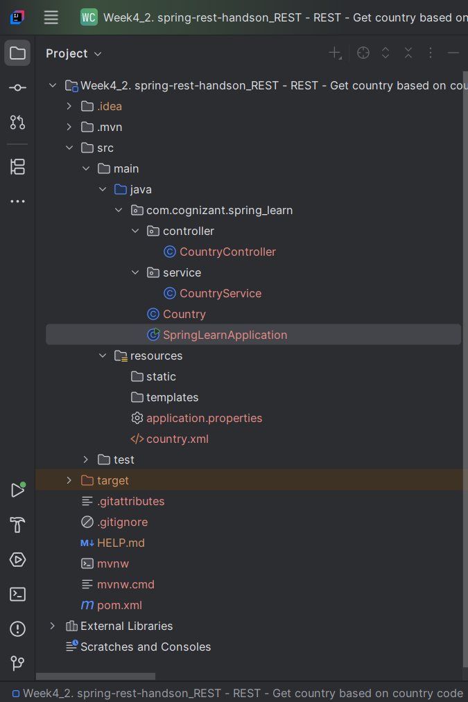

**Country.java**

package com.cognizant.spring_learn;  
  
public class Country {  
 private String code;  
 private String name;  
  
 // Getters and Setters  
 public String getCode() {  
 return code;  
 }  
  
 public void setCode(String code) {  
 this.code = code;  
 }  
  
 public String getName() {  
 return name;  
 }  
  
 public void setName(String name) {  
 this.name = name;  
 }  
  
 // toString for logging  
 @Override  
 public String toString() {  
 return "Country{" +  
 "code='" + code + '\'' +  
 ", name='" + name + '\'' +  
 '}';  
 }  
}

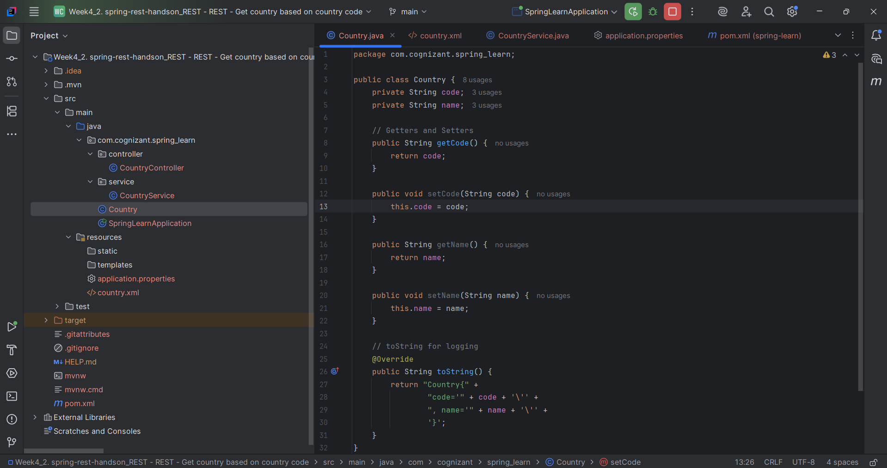

**country.xml (src/main/resources)**

<beans xmlns="http://www.springframework.org/schema/beans"  
 xmlns:xsi="http://www.w3.org/2001/XMLSchema-instance"  
 xsi:schemaLocation="http://www.springframework.org/schema/beans  
 http://www.springframework.org/schema/beans/spring-beans.xsd">  
  
 <bean id="country" class="com.cognizant.spring_learn.Country">  
 <property name="code" value="IN"/>  
 <property name="name" value="India"/>  
 </bean>  
  
 <bean id="countryList" class="java.util.ArrayList">  
 <constructor-arg>  
 <list>  
 <bean class="com.cognizant.spring_learn.Country">  
 <property name="code" value="IN"/>  
 <property name="name" value="India"/>  
 </bean>  
 <bean class="com.cognizant.spring_learn.Country">  
 <property name="code" value="US"/>  
 <property name="name" value="United States"/>  
 </bean>  
 <bean class="com.cognizant.spring_learn.Country">  
 <property name="code" value="CN"/>  
 <property name="name" value="China"/>  
 </bean>  
 </list>  
 </constructor-arg>  
 </bean>  
</beans>

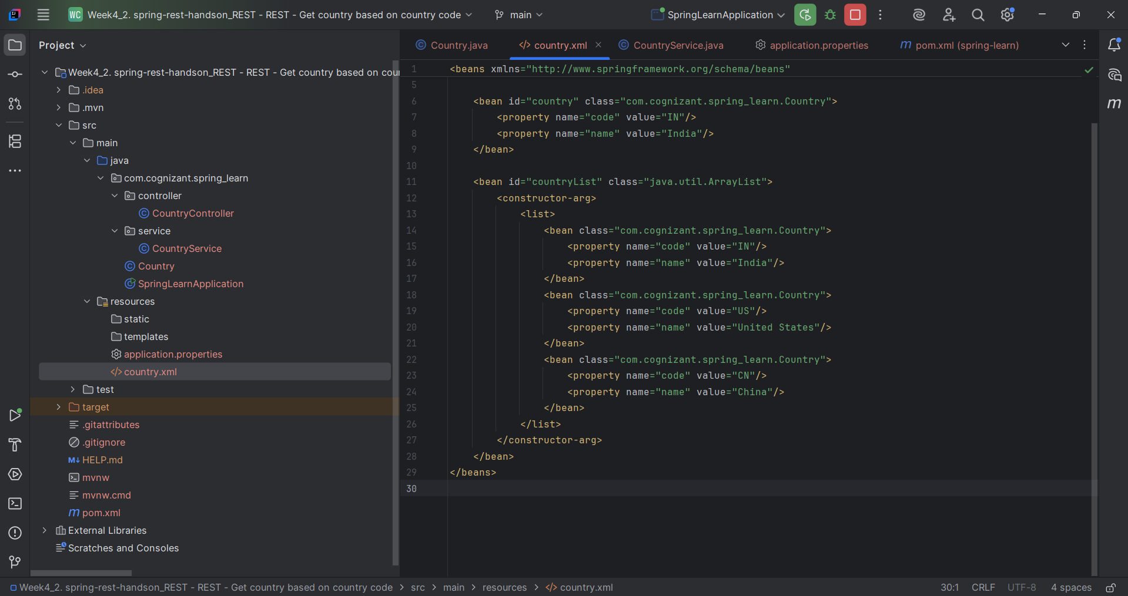

**application.properties (src/main/resources)**

spring.application.name=spring-learn  
logging.level.com.cognizant=DEBUG  
server.port=8083

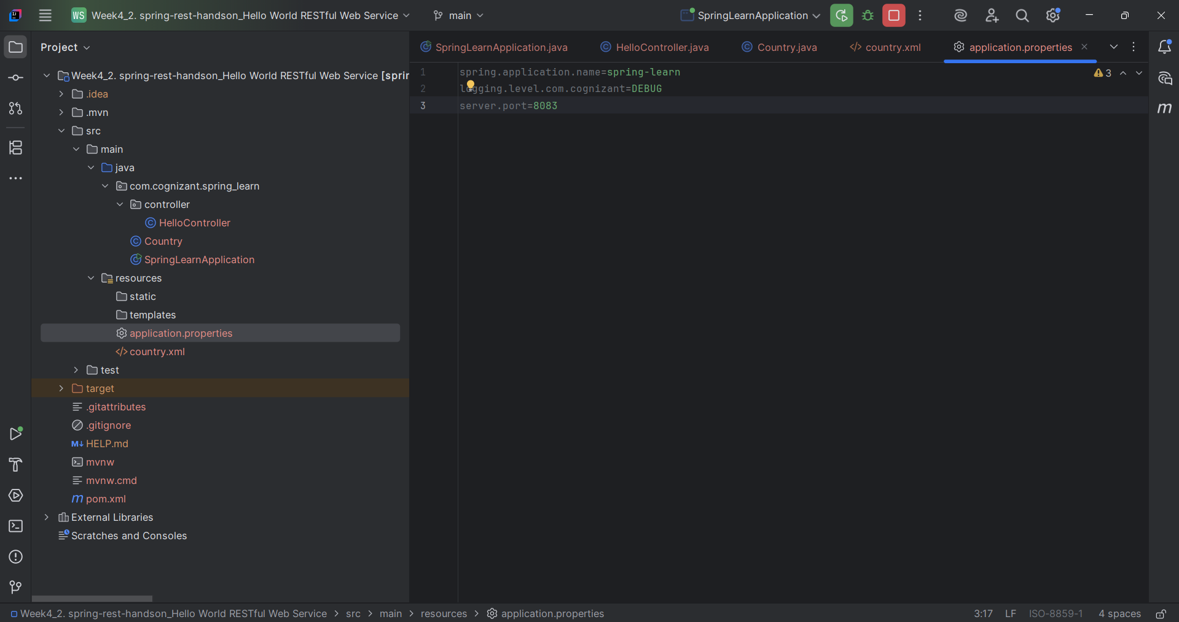

**SpringLearnApplication.java**

package com.cognizant.spring_learn;  
  
import org.slf4j.Logger;  
import org.slf4j.LoggerFactory;  
import org.springframework.boot.SpringApplication;  
import org.springframework.boot.autoconfigure.SpringBootApplication;  
import org.springframework.context.ApplicationContext;  
import org.springframework.context.support.ClassPathXmlApplicationContext;  
  
@SpringBootApplication  
public class SpringLearnApplication {  
  
 private static final Logger *LOGGER* = LoggerFactory.*getLogger*(SpringLearnApplication.class);  
  
 public static void main(String[] args) {  
 *LOGGER*.info("START");  
 SpringApplication.*run*(SpringLearnApplication.class, args);  
 *displayCountry*();  
 *LOGGER*.info("END");  
 }  
  
 public static void displayCountry() {  
 ApplicationContext context = new ClassPathXmlApplicationContext("country.xml");  
 Country country = (Country) context.getBean("country", Country.class);  
 *LOGGER*.debug("Country : {}", country.toString());  
 }  
}

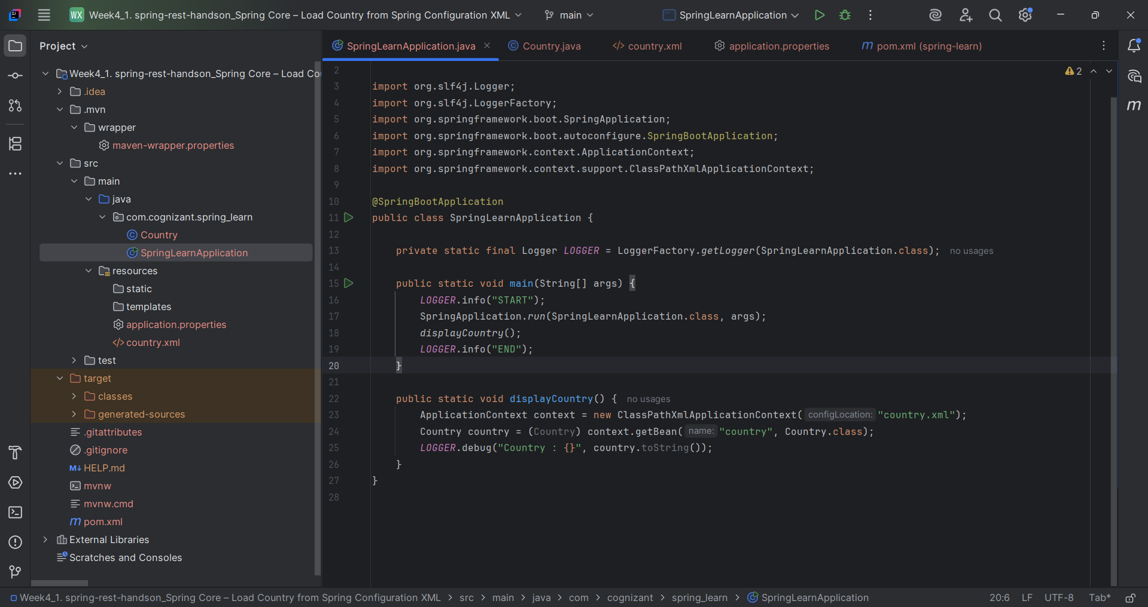

**CountryController.java**

package com.cognizant.spring_learn.controller;  
  
import com.cognizant.spring_learn.Country;  
import com.cognizant.spring_learn.service.CountryService;  
import org.slf4j.Logger;  
import org.slf4j.LoggerFactory;  
import org.springframework.beans.factory.annotation.Autowired;  
import org.springframework.web.bind.annotation.*;  
  
@RestController  
public class CountryController {  
  
 private static final Logger *LOGGER* = LoggerFactory.*getLogger*(CountryController.class);  
  
 @Autowired  
 private CountryService countryService;  
  
 @GetMapping("/countries/{code}")  
 public Country getCountry(@PathVariable String code) {  
 *LOGGER*.info("START: getCountry");  
 Country country = countryService.getCountry(code);  
 *LOGGER*.debug("Country found: {}", country);  
 *LOGGER*.info("END: getCountry");  
 return country;  
 }  
}

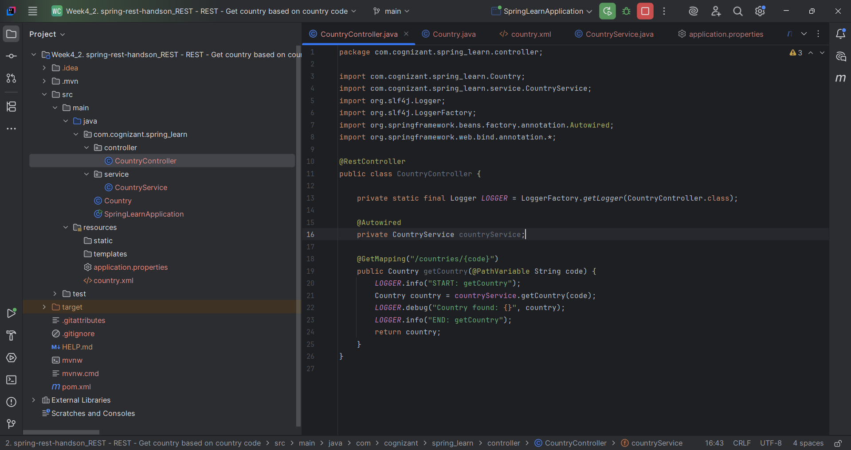

**CountryService.java**

package com.cognizant.spring_learn.service;  
  
import com.cognizant.spring_learn.Country;  
import org.springframework.context.ApplicationContext;  
import org.springframework.context.support.ClassPathXmlApplicationContext;  
import org.springframework.stereotype.Service;  
  
import java.util.List;  
  
@Service  
public class CountryService {  
  
 public Country getCountry(String code) {  
 ApplicationContext context = new ClassPathXmlApplicationContext("country.xml");  
 List<Country> countries = context.getBean("countryList", List.class);  
  
 return countries.stream()  
 .filter(country -> country.getCode().equalsIgnoreCase(code))  
 .findFirst()  
 .orElse(null); // or throw exception  
 }  
}

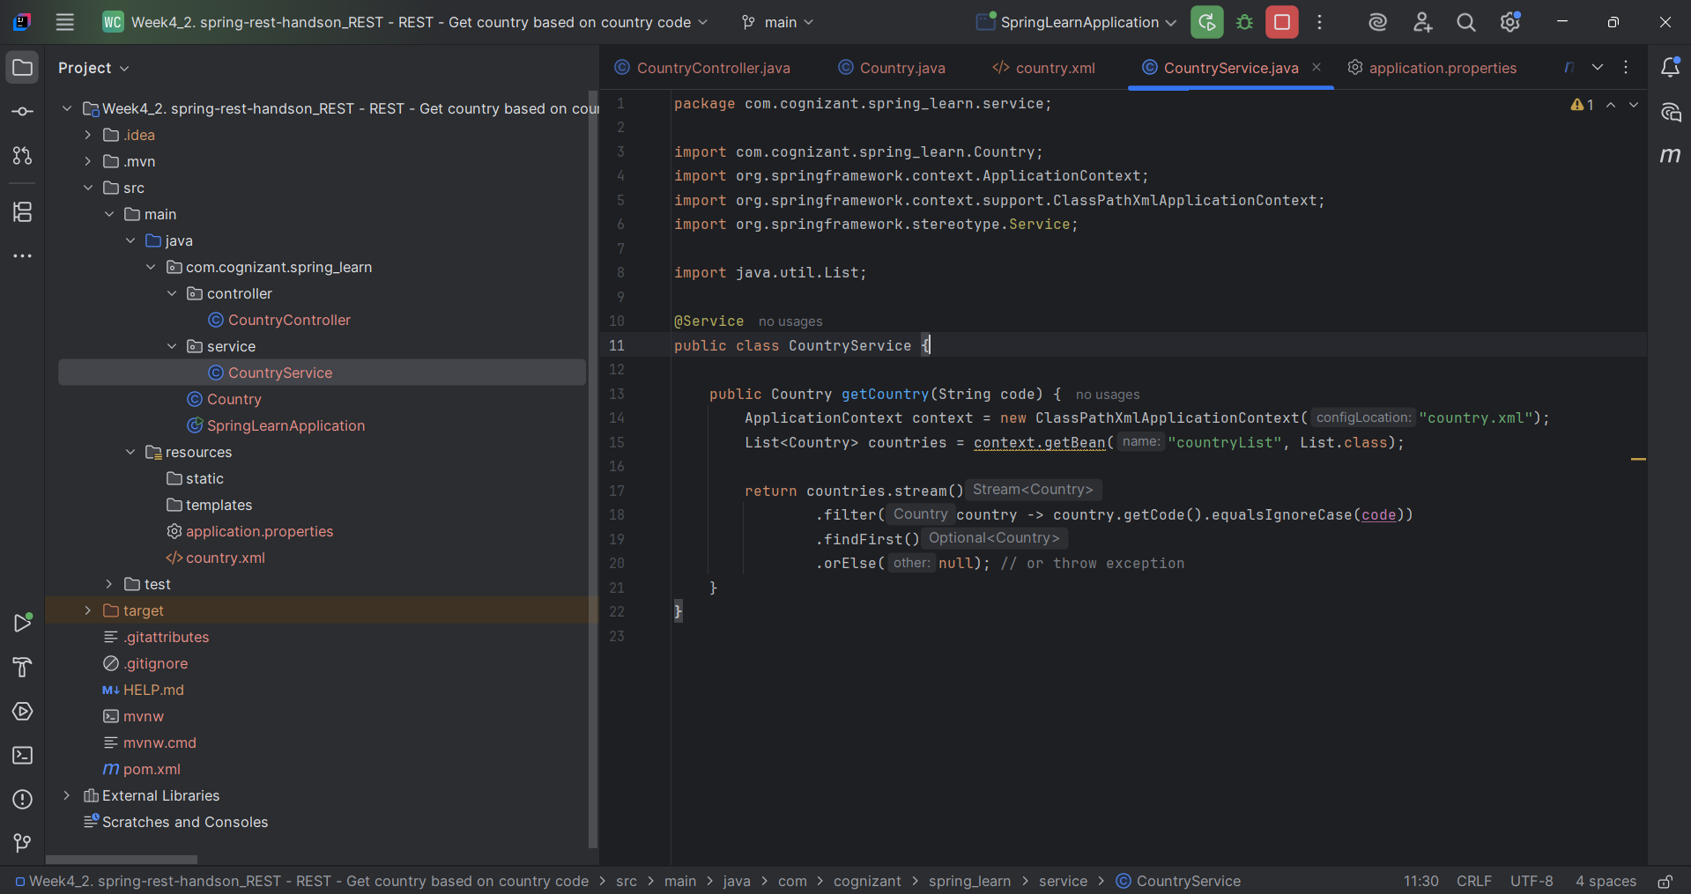

**pom.xml**

<?xml version="1.0" encoding="UTF-8"?>  
<project xmlns="http://maven.apache.org/POM/4.0.0" xmlns:xsi="http://www.w3.org/2001/XMLSchema-instance"  
 xsi:schemaLocation="http://maven.apache.org/POM/4.0.0 https://maven.apache.org/xsd/maven-4.0.0.xsd">  
 <modelVersion>4.0.0</modelVersion>  
 <parent>  
 <groupId>org.springframework.boot</groupId>  
 <artifactId>spring-boot-starter-parent</artifactId>  
 <version>3.5.3</version>  
 <relativePath/> <!-- lookup parent from repository -->  
 </parent>  
 <groupId>com.cognizant</groupId>  
 <artifactId>spring-learn</artifactId>  
 <version>0.0.1-SNAPSHOT</version>  
 <name>spring-learn</name>  
 <description>Demo project for Spring Boot</description>  
 <url/>  
 <licenses>  
 <license/>  
 </licenses>  
 <developers>  
 <developer/>  
 </developers>  
 <scm>  
 <connection/>  
 <developerConnection/>  
 <tag/>  
 <url/>  
 </scm>  
 <properties>  
 <java.version>17</java.version>  
 </properties>  
 <dependencies>  
 <dependency>  
 <groupId>org.springframework.boot</groupId>  
 <artifactId>spring-boot-starter-web</artifactId>  
 </dependency>  
  
 <dependency>  
 <groupId>org.springframework.boot</groupId>  
 <artifactId>spring-boot-devtools</artifactId>  
 <scope>runtime</scope>  
 <optional>true</optional>  
 </dependency>  
 <dependency>  
 <groupId>org.springframework.boot</groupId>  
 <artifactId>spring-boot-starter-test</artifactId>  
 <scope>test</scope>  
 </dependency>  
 </dependencies>  
  
 <build>  
 <plugins>  
 <plugin>  
 <groupId>org.springframework.boot</groupId>  
 <artifactId>spring-boot-maven-plugin</artifactId>  
 </plugin>  
 </plugins>  
 </build>  
  
</project>

**Output:**

